**1. Download MySQL server for your OS on VM.**

**2. Install MySQL server on VM.**

Перевірка наявності на сервері



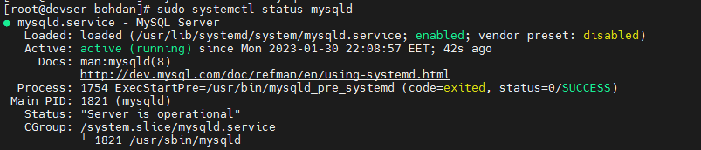

**3. Select a subject area and describe the database schema, (minimum 3 tables)**

**4. Create a database on the server through the console.**

Country (name, region)

Fly (type, number, date)

Travel agency (name, phone)

